Levi, ch. 7: The purchasing-power parity principle (p. 143)

Idea → trade between countries → equalisation of prices…

3 versions
- The Law of One Price (price of one good)
- Absolute Purchasing Power Parity (absolute PPP, level of price index)
- Relative Purchasing Power Parity (relative PPP, change in price index)

The “Law” of One Price (p. 143)

Traded products

- If no transportation and insurance costs → commodity arbitrage ⇒ same price

- With same transportation costs
- Sale of same product into two countries → same price (otherwise higher profits from selling to country with high price
- Outside buyer → only buy from country with lowest price
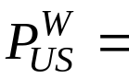 price of product (Wine) in US (in $)
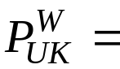 price of product in UK (in £)

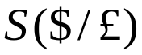 = spot exchange rate, $ per £

Same price in same currency, in $



Alternatively, in £:

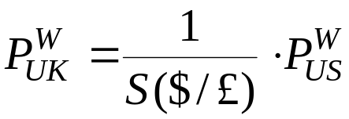

Would we expect the “Law of One Price” to hold for non-traded goods?

Absolute form of PPP condition (p. 144)

“General price levels” / price indices identical when expressed in same currency



“Problems”
- Traded goods → different amounts of traded goods in price indices → wine consumed a lot in France, beer in U.K.
- Non-traded goods → would price of e.g. cleaning service be the same in Estonia and Finland?
- NB: Empirical question whether absolute PPP holds!

Relative form of PPP (p. 145)

NB: Price levels can be very different but still move in parallel in two countries ⇒ changes in price level, i.e. inflation, could still be same → relative PPP…

New notation

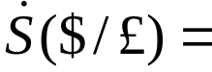 relative change in spot exchange rate over a year (or another chosen a period)
→
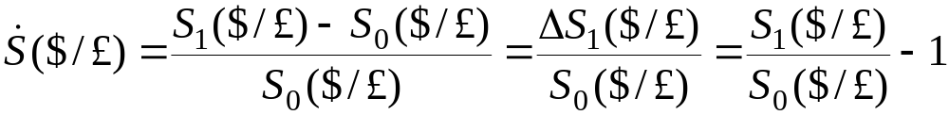

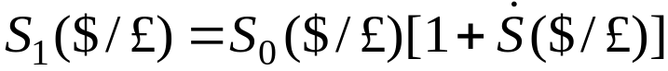 ← Rearranged (from last term above)

Exchange rate year 1 =
Exchange rate year 0 × (1 + relative change in exchange rate)
More notation

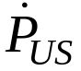 = relative change in US price index = US inflation
 = relative change in UK price index = UK inflation

Deriving relative PPP

Assume Absolute PPP holds → this year and next year

This year:

Next year:

US price level next year = Exchange rate next year × UK price level next year ☺

Divide Absolute PPP equation next year with Absolute PPP equation this year:

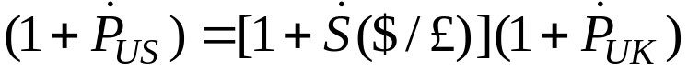
⇒
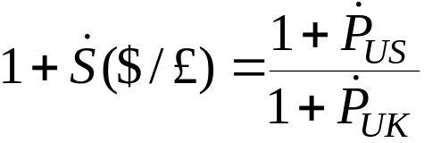
⇒
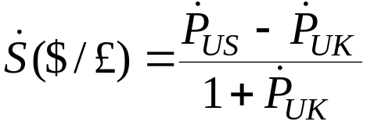

Relative PPP ⇒ relative change in exchange rate linked to domestic and foreign inflation rates

If  small → small error using the following approximation:

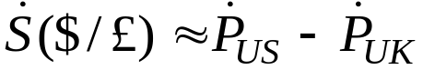
→
In words: relative depreciation of $ (vs. £) = difference between rates of inflation in the US and the UK
- If Relative PPP → relative change in exchange rate = inflation differential
NB: Relative PPP can be satisfied even if absolute PPP is not satisfied

Proof:

, where e.g. 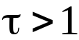 implies that the US price level is higher than the UK price level (measured in $), i.e. Absolute PPP not satisfied

Divide “next year” by “this year”:

⇒
← Relative PPP

Efficient markets (or speculative) form of PPP (p. 147)

Notation

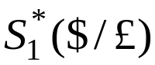 =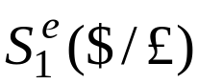= expected spot exchange rate next year, $ per £
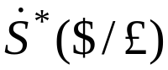 = expected relative change in spot exchange rate (from this to next year)
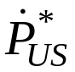 = expected inflation in US next year
 = expected inflation in UK next year

Speculation / investment in basket of goods (of price index)
- Basket of non-perishable goods

Invest 1 $ in US basket of non-perishable goods

Expected value after 1 year = 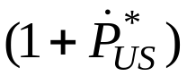

Invest 1 $ in UK basket of goods of non-perishable goods

Expected value after 1 year = 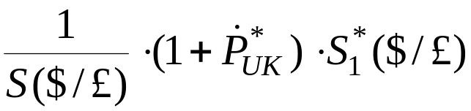

to £

next year to $

Use = 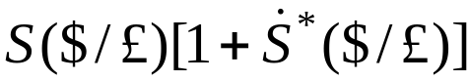

Expected value next year = 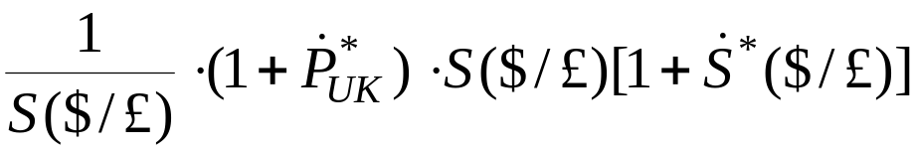
⇒
Expected value next year = 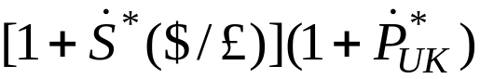

Assume speculator / investor risk-neutral → expected return to both investments identical

=
⇒
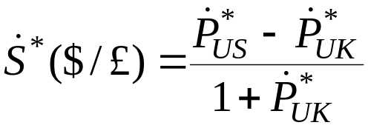

Approximation:

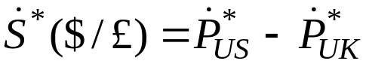

The “efficient markets relative PPP” / “speculative form of relative PPP”

NB: Expectations appear in “efficient markets relative PPP”
- Very different economic contents / interpretations than for normal “Relative PPP”
- Even if normal relative PPP eventually turns out not to hold, the efficient markets relative PPP might still hold ← efficient markets relative PPP is only supposed to hold in expectations ex ante
Empirical evidence on PPP (p. 148)

Tests of the Law of One Price
- Not satisfied for many goods – at least at short time horizons
- Hamburgers in Tallinn and Helsinki
- Would not expect the Law of One Price to be satisfied if prices move slowly and exchange rates fluctuate a lot…

Tests of absolute PPP
- Generally weak support
- Strongest for indices of traded goods, less strong for indices of non-traded goods ☺

Tests of relative PPP
- Generally some support → especially over longer horizons
- Strong support for countries experiencing very high inflation (e.g. 100% per year)
- Convergence of price levels in e.g. Estonia ⇒ ☹

Does absolute PPP and/or relative PPP hold for the EU countries?
- Table next page: domestic consumer price levels converted to same currency (euro)
Comparative price levels of actual individual consumption (ESA2010), EU15 = 100

 | 95 | 96 | 97 | 98 | 99 | 00 | 01 | 02 | 03 | 04 | 05 | 06 | 07 | 08 | 09 | 10 | 11 | 12 | 13 | 14 | 15 | 16 | 17 | 18 | 19 | 20 | 21 | 22 | 23 | 24
BE | 109 | 105 | 101 | 102 | 101 | 97 | 98 | 97 | 99 | 100 | 100 | 100 | 102 | 105 | 107 | 105 | 105 | 104 | 104 | 101 | 99 | 103 | 105 | 106 | 105 | 104 | 104 | 106 | 107 | 107
BG | 24 | 19 | 24 | 28 | 28 | 30 | 32 | 32 | 32 | 33 | 34 | 37 | 39 | 42 | 44 | 43 | 43 | 42 | 41 | 40 | 39 | 40 | 42 | 43 | 44 | 46 | 47 | 50 | 51 | 51
CZ | 35 | 37 | 37 | 40 | 39 | 40 | 42 | 49 | 47 | 48 | 51 | 55 | 55 | 64 | 61 | 62 | 65 | 62 | 59 | 54 | 54 | 56 | 58 | 61 | 62 | 62 | 64 | 71 | 75 | 72
DK | 136 | 134 | 129 | 127 | 129 | 128 | 132 | 132 | 135 | 134 | 134 | 132 | 128 | 131 | 133 | 131 | 131 | 131 | 130 | 129 | 125 | 130 | 130 | 129 | 129 | 129 | 129 | 133 | 129 | 128
DE | 110 | 105 | 101 | 101 | 99 | 98 | 99 | 99 | 98 | 96 | 96 | 95 | 94 | 97 | 98 | 97 | 96 | 94 | 96 | 94 | 93 | 95 | 96 | 96 | 97 | 97 | 98 | 99 | 99 | 98
EE | 34 | 41 | 42 | 45 | 47 | 47 | 50 | 50 | 51 | 52 | 54 | 58 | 61 | 65 | 63 | 62 | 63 | 63 | 65 | 65 | 64 | 66 | 70 | 72 | 74 | 74 | 77 | 84 | 85 | 87
IE | 88 | 90 | 98 | 95 | 99 | 102 | 107 | 111 | 114 | 114 | 114 | 116 | 118 | 124 | 122 | 115 | 115 | 112 | 115 | 116 | 114 | 117 | 121 | 122 | 125 | 130 | 132 | 131 | 131 | 127
GR | 74 | 76 | 77 | 74 | 78 | 75 | 74 | 74 | 78 | 79 | 80 | 81 | 83 | 86 | 88 | 90 | 89 | 86 | 82 | 78 | 75 | 76 | 76 | 76 | 76 | 76 | 76 | 76 | 76 | 75
ES | 82 | 84 | 79 | 79 | 80 | 79 | 80 | 79 | 82 | 84 | 84 | 84 | 86 | 90 | 92 | 93 | 92 | 89 | 89 | 86 | 84 | 86 | 86 | 87 | 87 | 89 | 88 | 88 | 85 | 81
FR | 108 | 106 | 102 | 101 | 99 | 97 | 96 | 95 | 100 | 101 | 99 | 100 | 100 | 104 | 105 | 103 | 103 | 101 | 100 | 99 | 97 | 98 | 100 | 100 | 98 | 98 | 98 | 96 | 96 | 97
HR | 55 | 54 | 54 | 56 | 54 | 54 | 58 | 58 | 58 | 60 | 63 | 63 | 62 | 66 | 66 | 66 | 64 | 61 | 60 | 58 | 56 | 57 | 59 | 60 | 60 | 59 | 60 | 62 | 65 | 66
IT | 82 | 91 | 91 | 90 | 90 | 90 | 93 | 95 | 96 | 97 | 97 | 96 | 95 | 96 | 97 | 94 | 95 | 94 | 95 | 95 | 93 | 94 | 95 | 94 | 92 | 92 | 92 | 91 | 89 | 88
CY | 78 | 78 | 78 | 79 | 79 | 80 | 81 | 82 | 83 | 84 | 84 | 85 | 81 | 84 | 86 | 89 | 90 | 90 | 89 | 86 | 82 | 82 | 83 | 84 | 84 | 84 | 85 | 85 | 84 | 85
LV | 32 | 35 | 39 | 40 | 42 | 47 | 47 | 47 | 46 | 47 | 48 | 54 | 60 | 67 | 64 | 59 | 61 | 61 | 62 | 61 | 60 | 62 | 63 | 65 | 66 | 66 | 69 | 73 | 74 | 69
LT | 24 | 29 | 35 | 37 | 38 | 43 | 44 | 44 | 43 | 44 | 46 | 48 | 51 | 57 | 57 | 54 | 55 | 54 | 54 | 53 | 52 | 54 | 56 | 57 | 58 | 59 | 61 | 67 | 70 | 70
..

Source: Eurostat, https://ec.europa.eu/eurostat/data/database (code: prc_ppp_ind, subcodes: PLI_EU15_2020, PLI_EU27_2020); imputations for 21-24

Findings
- Price levels are not the same across many of the EU28 countries ⇒ absolute PPP hardly ever holds! ← Germany, France
- Some countries (e.g. Denmark, Cyprus) → difference of price levels fairly constant ⇒ relative PPP likely satisfied
- Some countries (e.g. Czechia, Estonia) → difference changes (shrinks) over time “price level convergence” ⇒ relative PPP is not satisfied
More in O&R, ch. 4

Reasons for departures from PPP (p. 151)

- Transportation costs
- Information problems
- Import (and export) tariffs, quotas
- Indirect taxes (if not removed)

- Different baskets of goods (beer in DE, wine in FR)
- Perishable goods → apples, electricity
- Non-traded goods?
- PPP may also hold for non-traded goods if production factors can move freely between production of traded and non-traded goods
  - Complicated interaction between movement of production factors and sectoral productivity developments… ← More in O&R, ch. 4

Levi ch. 8: Interest parity

- CIP = Covered Interest Parity (= Covered Interest rate Parity)
- UIP = Uncovered Interest Parity (= Uncovered Interest rate Parity)

Levi → sometimes approximation, sometimes not approximation!

◆ An aside: Approximations

Compounding of interest

Assume
- Interest rate = r per year (constant)
- Interest paid annually (after one year) or at contract expiry ← “compounding frequency”

NB: Interest rate r in Levi is nominal interest rate (not real one as in O&R)
- Macroeconomists often use letter i to indicate nominal interest rate
Invest 1 €
After 1 year → 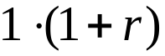 = 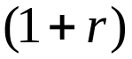
After 2 years → 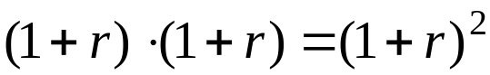
After 3 years → 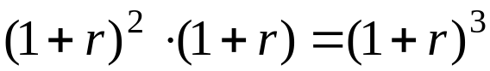
…
After n years → 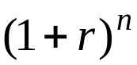
After  year → 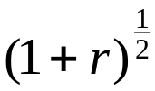 Proof: · = 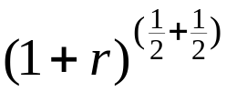 = 1 + r ☺
After 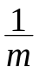 year → 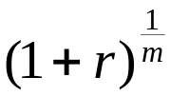

Compounding → accumulation of interest → “interest of interest”

Invest A € at the fixed interest rate r
- After 3.5 years → 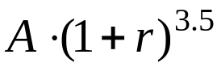

Approximation

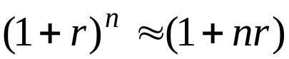

Low-tech proof:
For n = 2 years →
For n = 3 years →

Example 1: r = 5%, n = 2
- Exact → 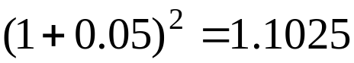, approximation → 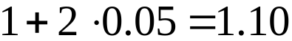
- 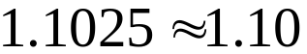 ☺

Example 2 → r = 4%, n = ¼ (3 months)
- Exact → 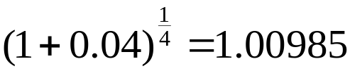, approximation → 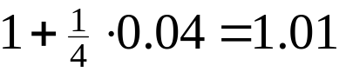
- 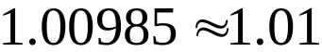 ☺

NB: Approximation not good if r and n are large → try r = 25% and n = 3 ☹

End of aside 
The investment and borrowing criteria (p. 160)

Investment (p. 160)

Investor → invest 1 $ for 3 months (= ¼ year)
- Invest in $-denominated security
- Change spot to £, invest in £-denominated security, buy $ (for £) 3-month forward

NB: Exchange rate risk covered / hedged!

Forward contract
- Contracting “now”, transaction at “forwarded” / future time
- Main difference from spot markets → ensure that contract carried through at future time transaction
- OTC (“Over The Counter”), future markets (with complicated guarantee deposits)
- Used for hedging (here of exchange rate risk) ← but also kerosine prices, crude oil, raw materials, …

Volumes of forward contracts → https://www.bis.org/publications/202509-commentary-otc-derivatives + pdf report (Table 1, 16)
Assume → no transaction costs

- Return on $-denominated security = 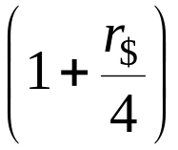, where 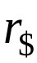 = annual(ised) return in $

  - NB: Return is approximation → 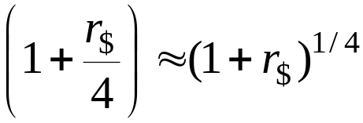

- Return on £-denominated security = 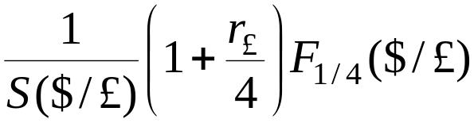 = 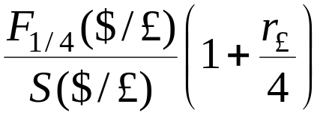, where 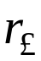 = annualised return in £

NB: Forward contract ⇒ no exchange rate risk from investing in £-denominated security!

Invest in $-denominated security → >

Invest in £-denominated security → <

Indifference → =

NB: Parity of returns → “interest parity”
Rewrite CIP

=
⇒
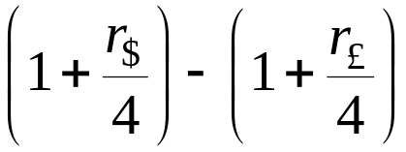 = – 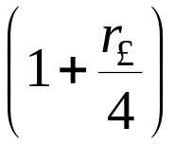
⇒
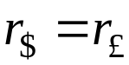 + 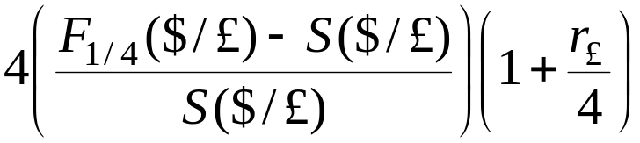 (CIP, 3-months)

If 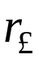 small → approximation:

+ 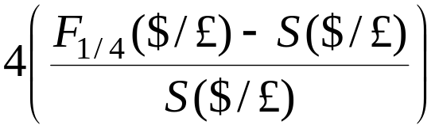 (CIP, 3-months, approximation)

“Covered yield on 3-month £-denominated asset”
Terminology

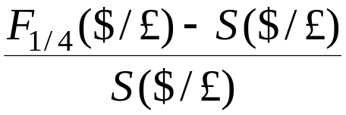 = 3 months forward premium on £ vs. $ with delivery in 3 months
- Forward premium if > 0; Forward discount if < 0)
- Forward premium on £ vs. $ > 0 ← £ more expensive / pricy (in terms of $) forward than spot ← “more dollars to buy a pound”

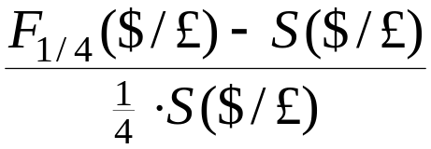 = = annualised forward premium
on £ vs. $ (for 3-month contract)

Repeat CIP (from previous slide):

+

If e.g. 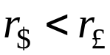, investor will only invest in $-denominated asset if there is a (sufficiently large) forward discount on £ vs. $ (“capital loss on £-denominated asset”)
Example
- Interest rate on $-denominated 3-month bond = 5%
- Interest rate on £-denominated bond = 7%
- 3-month forward premium on £ vs. $ = -0.7% (forward discount)

CIP → +

CIP not satisfied here…

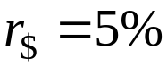
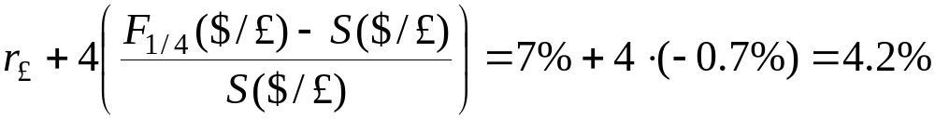

Best investment → $ denominated asset!

If 3-month forward premium = -0.5% (forward discount) → CIP holds!

Borrowing (p. 164)

Same “exercise” as with investment, but now borrow 3 months

Amount to repay if borrowing in $ =

Amount to repay if borrowing in £ =

Borrow in $ (instead of borrowing in £) if:

<

Borrow in £ (instead of borrowing in $) if:

>
Indifference (w.r.t. borrowing currency) if:

=

Indifference if CIP holds
Borrowing and investing for arbitrage profit (p. 165)

Now define DEV = deviation from CIP

DEV = –

If DEV > 0 → save in $, borrow in £ ⇒ profits > 0
If DEV < 0 → borrow in $, save in £ ⇒ profits > 0
→
Unlimited profit opportunities
→
Will this situation remain for long…?

NB: What is “carry trade”?

The covered interest parity condition (p. 166)

Idea of subsection
- “General case” → n years, borrowing or lending not specified
- First CIP derived without approximation(s), then approximation

CIP, n years, without approximations

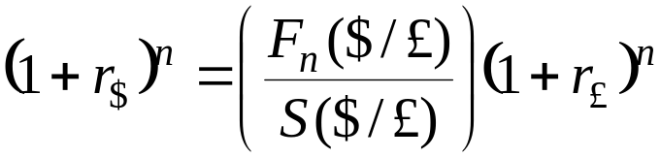

Rewrite

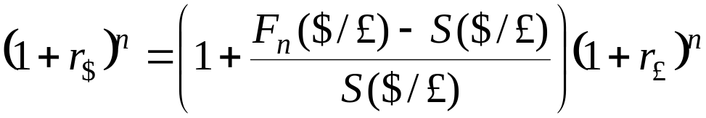

$ interest Forward £ interest
return, 1 + premium return
n years n years n year
Approximation:

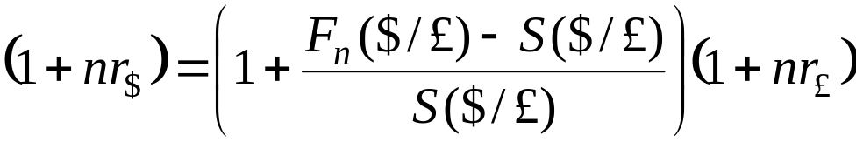
⇒
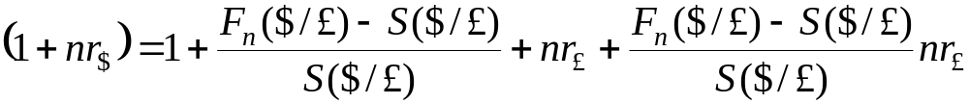

“Small”, 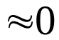
Approximation

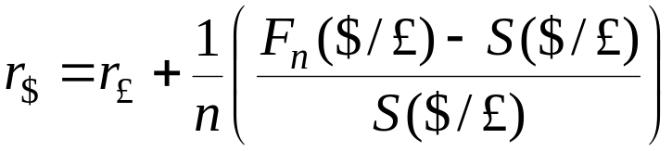

NB: Like CIP before; holds (approximately) for any investment horizon n

Market forces pulling towards CIP (p. 166)

CIP for 3-months:

+
⇒
= 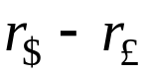

If LHS < RHS, e.g. point F 
Incentive → into $-denominated assets and out of £-denominated assets
- 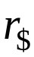 ↓ and/or ↑ ⇒ RHS ↓ ( )
- Buy $ for £ spot ⇒ 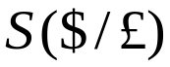 ↓ ($ spot appreciates), sell $ for £ forward ⇒ 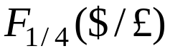 ↑ ($ forward depreciates) → forward premium on £ vs. $ ↑ → LHS ↑ ( )

If LHS > RHS, e.g. point A
Fill in yourself!
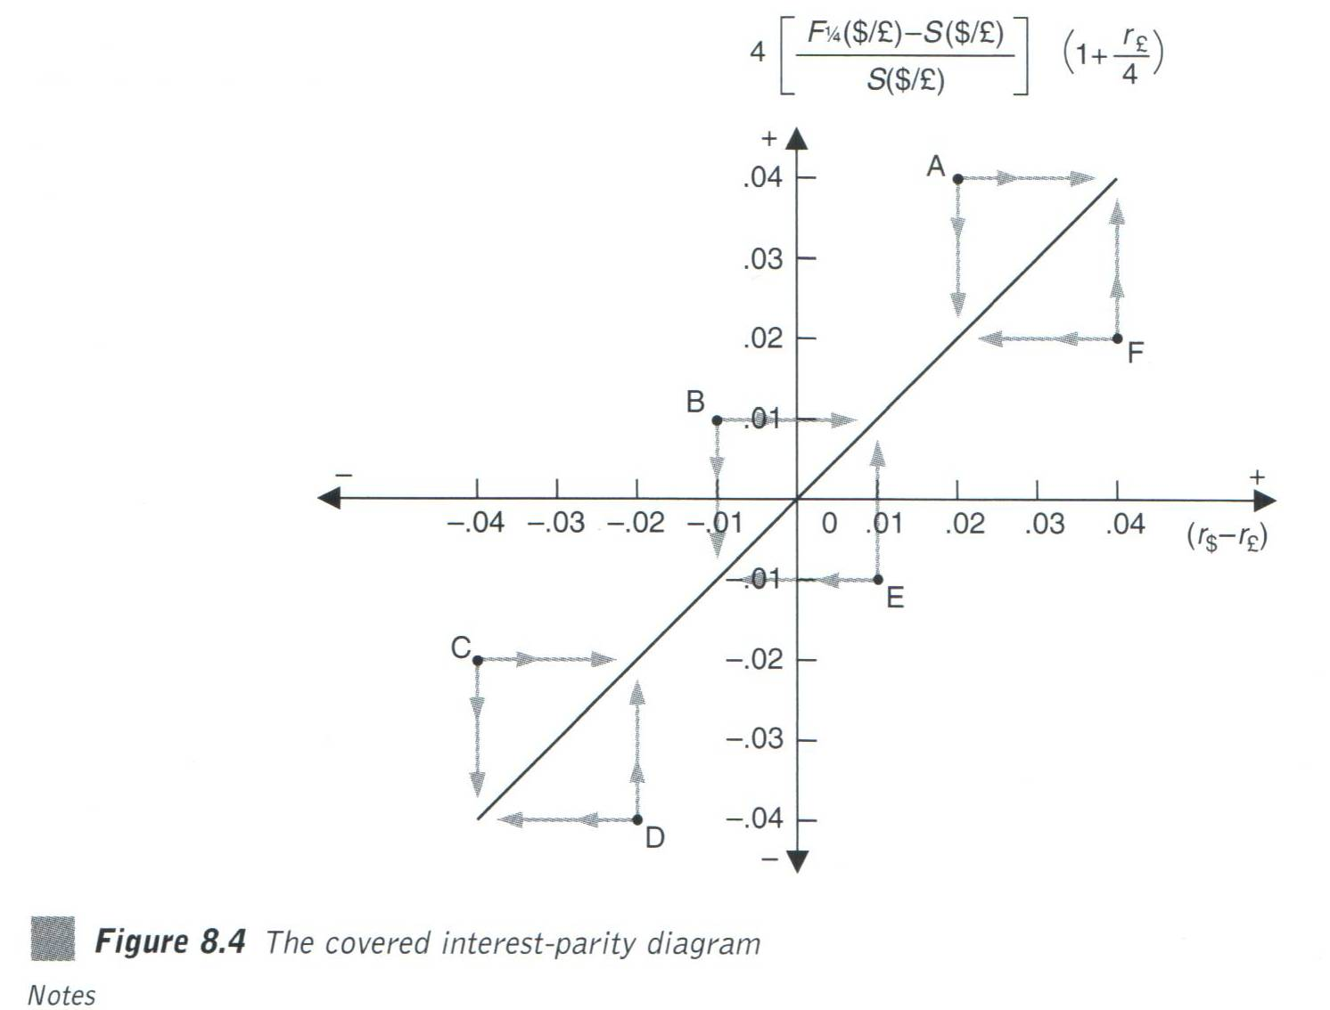

Combining PPP and interest parity [← Karsten: strange title!]

The Uncovered Interest Parity condition (p. 169)

Consider investors that engage in arbitrage, but who do not cover their exchange rate positions
→
Base investment decision on expected spot exchange rate

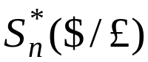 = expected spot exchange rate n years ahead

Return (after n years) investing in $-denominated asset → 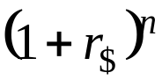

Expected return (after n years) investing in £-denominated asset → 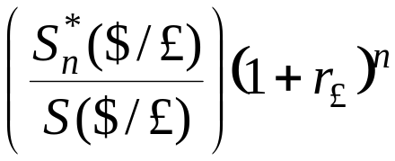

If risk neutral investors → only concerned about expected return
→
Uncovered Interest Parity (UIP), n years

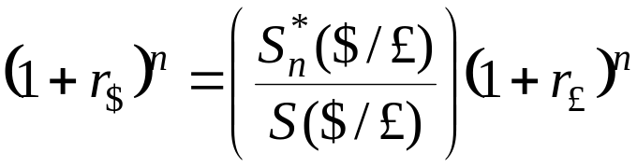

Define
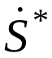 = the average annual expected relative change of exchange rate over next n year
→
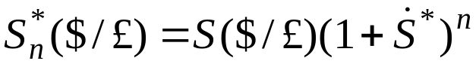

Insert in UIP:

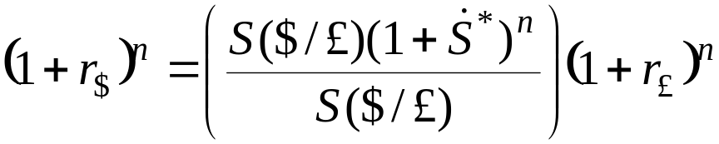
⇒
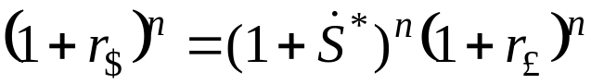
⇒
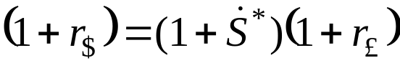

Approximation:

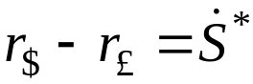

UIP → Interest differential = average annual relative change in expected exchange rate

Example: If 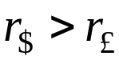, then 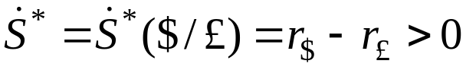, i.e. expected depreciation of $ vs. £

“Problem” with UIP → derived assuming risk neutrality

If risk aversion → add risk premium!
NB: Relationship between forward exchange rate and expected exchange rate

If risk-neutral investors (speculators) → 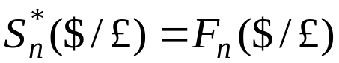
- If 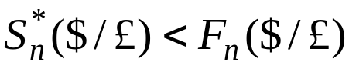 ⇒ sell £ forward [buy $ forward → expect less $ per £ than the forward rate]
- If 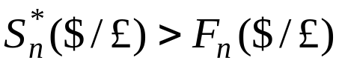 ⇒ buy £ forward [sell $ forward]

UIP sometimes derived by simply inserting into CIP
The interrelationship of the parity conditions (p. 170)

The expectations, speculative or efficient markets relative PPP: 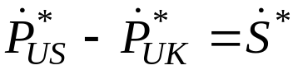

UIP: 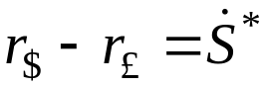

Both derived assuming risk neutrality

Combine:

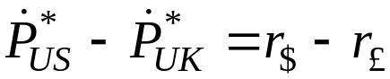
→
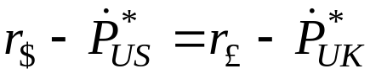

Expected real interest rates identical in “all” countries → Fisher-open condition
- Assumes that both relative PPP and expectations UIP hold
→
Tests of Fisher-open condition sometimes used to test for integration of economies
Why covered interest differences persist (p. 171)

1. Transaction costs
2. Political risks
3. Different tax policies
4. Liquidity differences between foreign and domestic securities

Re. 1: Transaction costs and interest parity

Transaction costs → “band” around parity in which gains from trades will be exceeded by transaction costs → arbitrage would be unprofitable

Costs of acquiring information (e.g. about financial products and their returns) may be different in different markets
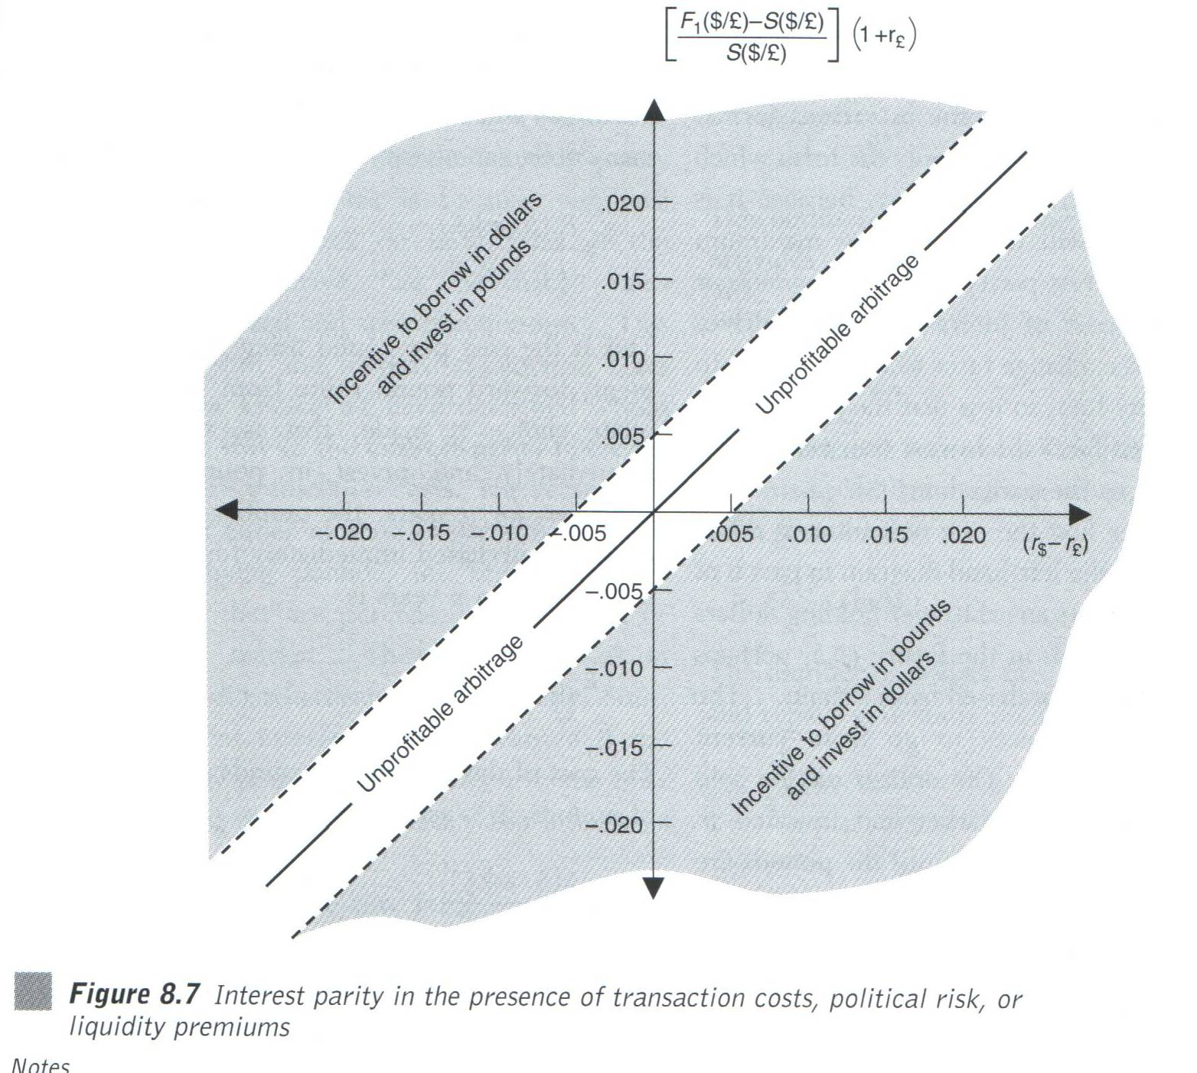
One year investment horizon
Re. 2): Political risk and interest parity

Political risks of investing in foreign country
- Assets frozen
- Inconvertible
- Partly or fully confiscated
- Tax increases

Political risks can also be positive → Switzerland less risky than Syria

Effect like transaction costs → band of “inactivity”

Re. 3): Taxes and interest parity

Taxes identical on total domestic and foreign returns → taxes do not affect allocation decision → CIP holds! Proof 

Differential taxes on capital gains and interest income

- Tax rate on capital gains = 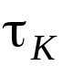
- Tax rate on interest income = 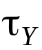

Often: <

Invest 1 $ one year

In $-denominated asset, receive after tax → 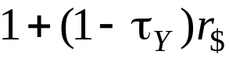

In £-denominated asset, receive before tax →
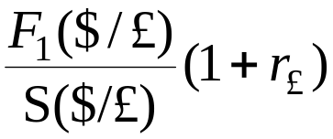 = 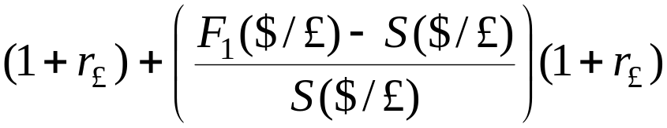

Interest
income Capital gains

In £-denominated asset, receive after tax →
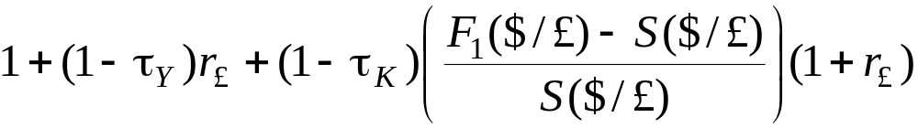

Same after-tax return if:
=
⇒
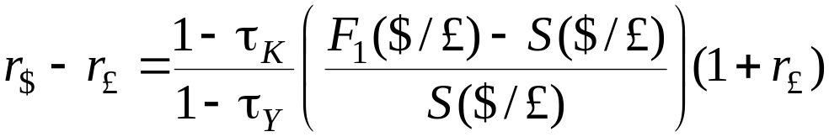

With tax only standard CIP if 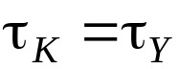!

Assume: positive forward premium
&
Capital tax lower rate than income tax rate 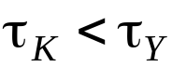
→
Interest differential < (adjusted) forward premium
→
Intuition: more favourable to invest in £-denominated assets as (positive) capital gain not taxed so much

Re. 4): Liquidity differences and interest parity

Foreign-denominated assets may be less liquid than domestic
→
If sell foreign-denominated asset before anticipated / maturity ⇒ maturity mismatch as forward contract “wrongly timed”
→
Risks and/or transaction costs

Liquidity preference → band of inactivity around interest parity

